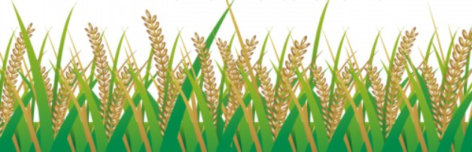

5:00-7:00 October 28, 2022

NJB PTA
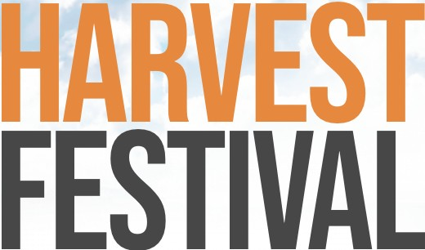
AND Costume Contest
ENTERTAINMENT• CRAFTS
• GAMES • FOOD • BOOK FAIR HELP RAISE MONEY FOR OUR SCHOLARS!

FREE ADMISSION/ 7300 MARIN AVE.

