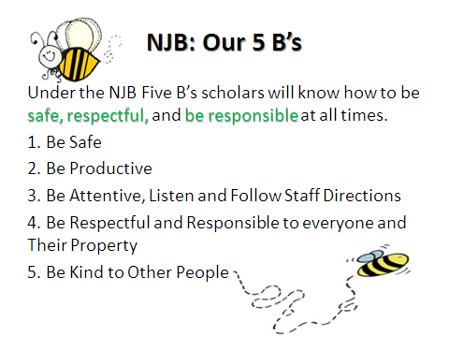
General Guidelines For Our Scholars To Be Successful!
BE SAFE | BE RESPECTFUL | BE RESPONSIBLE
• Choose actions that are safe that don’t hurt yourself or others. | • Use kind words and actions.  • Be thoughtful and considerate of others. | • Know the rules and understand your responsibility.
• Ask for adult help when needed. | • Be fair, take turns, and share. | • Make good decisions knowing the consequences of your choices.
• Be aware of your actions and how it might affect others. | • Clean up after yourself.  • Put yourself in the other person’s place. | • Accept responsibility for your actions.
• Strive to be positive. | • Pay attention to what others say to you. Be a good listener. | • Help others make appropriate choices.
• Use Lifelong Guidelines and LIFESKILLS to guide in your decisions. | • Respect other’s property and personal space.  • Use Lifelong Guidelines and LIFESKILLS to guide in your decisions. | • Apply all these ideas even when no one is watching.  • Use Lifelong Guidelines and LIFESKILLS to guide in your decisions.

Scholars will be expected to model and rules and procedures at all times. All NJB staff members will ensure and positively redirect scholars to correctly follow if expectations are not met.
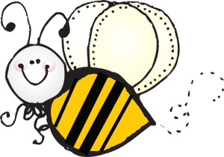
NJB
Office Area Rules and Procedures
BE SAFE | BE RESPECTFUL | BE RESPONSIBLE
• Always have a pass.  • Always walk with a peer. | • Keep hands to self.  • Walk quietly without talking through the front office entrance.  • Stand in front of the lower counter and wait for office staff to help you. | • Follow all directions given by office staff.  • Help others to remember and follow Lifelong Guidelines, LIFESKILLS and behavior expectations.

Scholars will be expected to model and rules and procedures at all times. All NJB staff members will ensure and positively redirect scholars to correctly follow if expectations are not met.

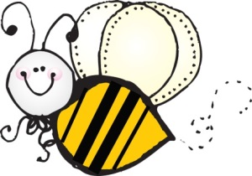
NJB
Cafeteria Area Rules and Procedures
BE SAFE | BE RESPECTFUL | BE RESPONSIBLE
• Walk in a straight, quiet line.  • Get your food one at a time.  • Walk to your table, sit and eat quietly.  • Raise your hands and get permission to leave the cafeteria. | • “Please and thank you” are expected.  • Use soft, inside voices.  • Eat your own food.  - Take your time and chew food slowly.  • Clean area before dismissal. | • Help others to remember and follow Lifelong Guidelines, LIFESKILLS and behavior expectations.

Scholars will be expected to model and rules and procedures at all times. All NJB staff members will ensure and positively redirect scholars to correctly follow if expectations are not met.

NJB
Assembly Rules and Procedures
BE SAFE | BE RESPECTFUL | BE RESPONSIBLE
• Sit in designated area with your class at all times.  • Wait for your teacher’s direction to enter and exit quietly. | • Enter quietly with walking feet.  • Be an active listener and participant. | • Follow all directions given by staff.  • Help others to remember and follow Lifelong Guidelines, LIFESKILLS and behavior expectations.

Scholars will be expected to model and rules and procedures at all times. All NJB staff members will ensure and positively redirect scholars to correctly follow if expectations are not met.

NJB
Hallways Rules and Procedures
BE SAFE | BE RESPECTFUL | BE RESPONSIBLE
• Carry a hall pass.  • Stay on walkways.  • Walking feet at all times.  • Report strangers or adults without badges to the closest staff member. | • Keep hands to self.  • Face forward.  • Walk quietly, voices off. | • Walk quietly to where you’re supposed to go.  • Help others to remember and follow Lifelong Guidelines, LIFESKILLS and behavior expectations.

Scholars will be expected to model and rules and procedures at all times. All NJB staff members will ensure and positively redirect scholars to correctly follow if expectations are not met.

NJB
Restroom Rules and Procedures
BE SAFE | BE RESPECTFUL | BE RESPONSIBLE
• Wait your turn.  • Use toilet quickly.  • Wash hands with soap, using only one pump.  - Use one paper-towel only. | • Walk quietly in the hallways.  - Leave restroom clean. (throw away trash, flush toilet)  - Use your designated bathroom only. | • Use the restroom appropriately.  • Do not play around in the restroom.  • Help others to remember and follow Lifelong Guidelines, LIFESKILLS and behavior expectations.

Scholars will be expected to model and rules and procedures at all times. All NJB staff members will ensure and positively redirect scholars to correctly follow if expectations are not met.

NJB
Playground Rules and Procedures
BE SAFE | BE RESPECTFUL | BE RESPONSIBLE
• Be within sight at all times.  • Stay on school grounds.  • Be aware of games and activities around you.  • Walk around ongoing games.  • Use equipment appropriately.  • Watch out for bystanders.  • Ask permission to leave playground.  • No sitting or standing on top of monkey bars.  • One scholar at a time across the monkey bars.  • Down the slide feet first.  • Keep shoes on at all times.  • Report strangers or adults without badges to the closest staff member. | • Keep hands to self.  • Play fair.  • Take turns.  • Share equipment.  • Include everyone.  • Follow game rules.  • If there is a conflict, works to problem solve.  • Throw away all trash.  • Use initiative to pick up trash. | • Help others to remember and follow Lifelong Guidelines, LIFESKILLS and behavior expectations.  • Work problems out or get help from an adult.  • Use playground equipment properly.  • Let a staff member know if there are any injuries.  • Help injured scholar to the office when needed.  • Use restroom and drink water before recess is over.

Scholars will be expected to model and rules and procedures at all times. All NJB staff members will ensure and positively redirect scholars to correctly follow if expectations are not met.

NJB
Playground and P.E. Equipment Rules and Procedures
BE SAFE | BE RESPECTFUL | BE RESPONSIBLE
• Kick soccer balls on the field only.  • Play basketball on the black top only.  • Kicking balls against the wall ball is not allowed.  • Place balls carefully in the cart/tub when the bell rings. | • Play fair.  • Share equipment.  • Include everyone.  • Follow game rules. | • Walk equipment back to the cart at the sound of the bell.  • Ask for adult help when needed.  • Help others to remember and follow Lifelong Guidelines, LIFESKILLS and behavior expectations.

Scholars will be expected to model and rules and procedures at all times. All NJB staff members will ensure and positively redirect scholars to correctly follow if expectations are not met.

NJB
Bell Rules and Procedures
BE SAFE | BE RESPECTFUL | BE RESPONSIBLE
• Stop playing and immediately “freeze.”  • Carry and return equipment.  • Walk to your class line promptly. | • Keep hands and feet to self.  • Stand quietly in assigned space in class line.  • Wait quietly for your teacher. | • Take your personal belongings (coats, etc.)  • Help others to remember and follow Lifelong Guidelines, LIFESKILLS and behavior expectations.

Scholars will be expected to model and rules and procedures at all times. All NJB staff members will ensure and positively redirect scholars to correctly follow if expectations are not met.

NJB
General Classroom Rules and Procedures
BE SAFE | BE RESPECTFUL | BE RESPONSIBLE
• Follow all directions given by teachers.  • Keep your hands and feet to yourself.  • Use classroom equipment and supplies appropriately.  • Walk at all times. | • Use active listening.  • Raise your hand when you have a question or comment.  • Work collaboratively with other scholars.  • Use inside voices.  • Respect others and their belongings.  • Wait patiently. | • Work on assigned tasks.  • Use your power words.  • Be an active participant.  • Work to problem-solve.  • Clean up after yourself.  • Make good choices.  • Be productive.  • Help others to remember and follow Lifelong Guidelines, LIFESKILLS and behavior expectations.

Scholars will be expected to model and rules and procedures at all times. All NJB staff members will ensure and positively redirect scholars to correctly follow if expectations are not met.

NJB
Rainy Day Rules and Procedures
BE SAFE | BE RESPECTFUL | BE RESPONSIBLE
• Stay in cafeteria.  • Ask permission to leave cafeteria.  • Wait until dismissed by an adult. | • Keep hands and feet to self.  • Stand quietly in assigned space in class line.  • Wait quietly to be dismissed. | • Help others to remember and follow Lifelong Guidelines, LIFESKILLS and behavior expectations.

Scholars will be expected to model and rules and procedures at all times. All NJB staff members will ensure and positively redirect scholars to correctly follow if expectations are not met.

NJB
Entering and Exiting the School Grounds
Rules and Procedures
BE SAFE | BE RESPECTFUL | BE RESPONSIBLE
• Walk at all times and be aware of your surroundings.  • Keep your hands and feet to yourself.  • Be within sight at all times.  - Stay on school grounds when entering.  - Eat a healthy breakfast before play.  - Dress appropriately for weather conditions.  - When exiting school go to your designated area or home immediately. | • Use active listening.  • Use your kind words.  • Bring your positive mindset and smile.  • Respect others and their belongings. | • Have all homework or tasks complete.  • Make good choices.  • Help others to remember and follow Lifelong Guidelines, LIFESKILLS and behavior expectations.  - Be ready for learning!

Scholars will be expected to model and rules and procedures at all times. All NJB staff members will ensure and positively redirect scholars to correctly follow if expectations are not met.

